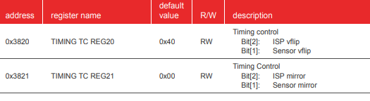For vertical flip

For mirroring





Test pattern color bar

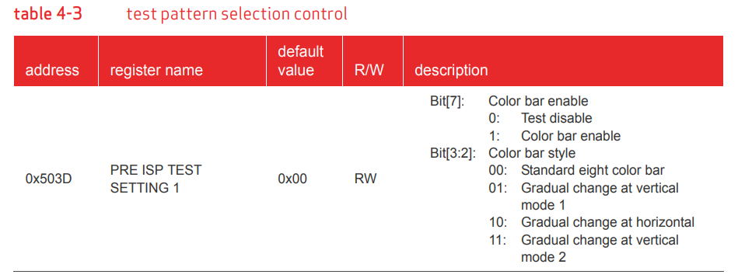

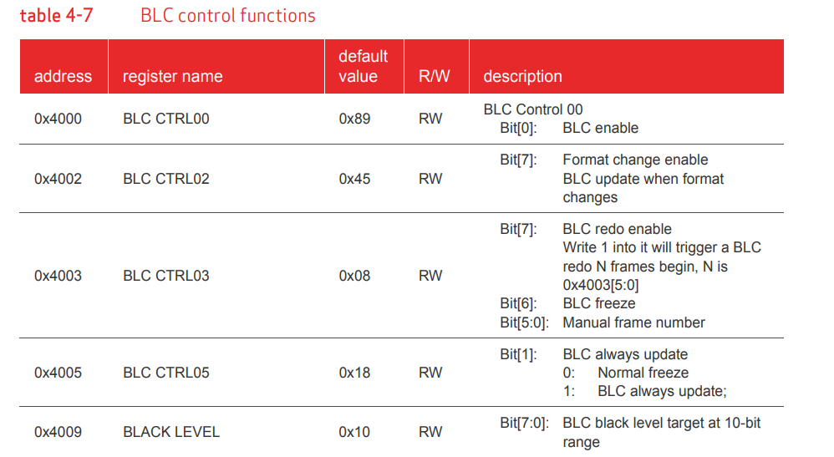Black level calibration

Defect pixel cancellation (DPC)

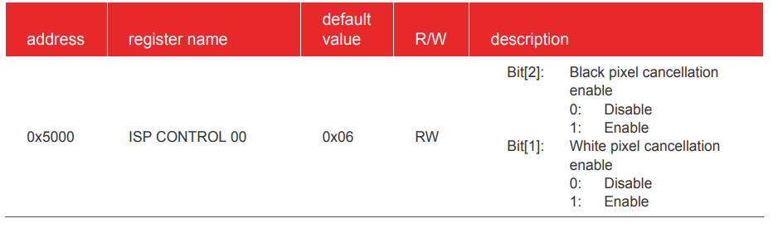

Color interpolation (CIP)

The CIP functions include de-noising of raw images, RAW to RGB interpolation, and edge enhancement. In sensor RAW format, each pixel will be either R, G or B. CIP will calculate the other two color values using the neighboring pixel of the same color. Thus, we can get the full RGB information for each pixel.

Pg#68

5.3 auto white balance (AWB)

The AWB makes sure that the white color is always a white color in different color temperatures. It supports manual white balance and auto white balance.

Page :64

Table: 5-3

5.4 raw gamma

The main purpose of the Gamma (GMA) function is to compensate for the non-linear characteristics of the sensor. GMA converts the pixel values according to the Gamma curve to compensate the sensor output under different light strengths. The non-linear gamma curve is approximately constructed with different linear functions. Raw gamma compensates the image in the RAW domain.

**5.11 special digital effects (SDE)**

The Special Digital Effects (SDE) functions include hue/saturation control, brightness, contrast, etc. SDE also supports negative, black/white, sepia, greenish, blueish, redish, solarize and other image effects.

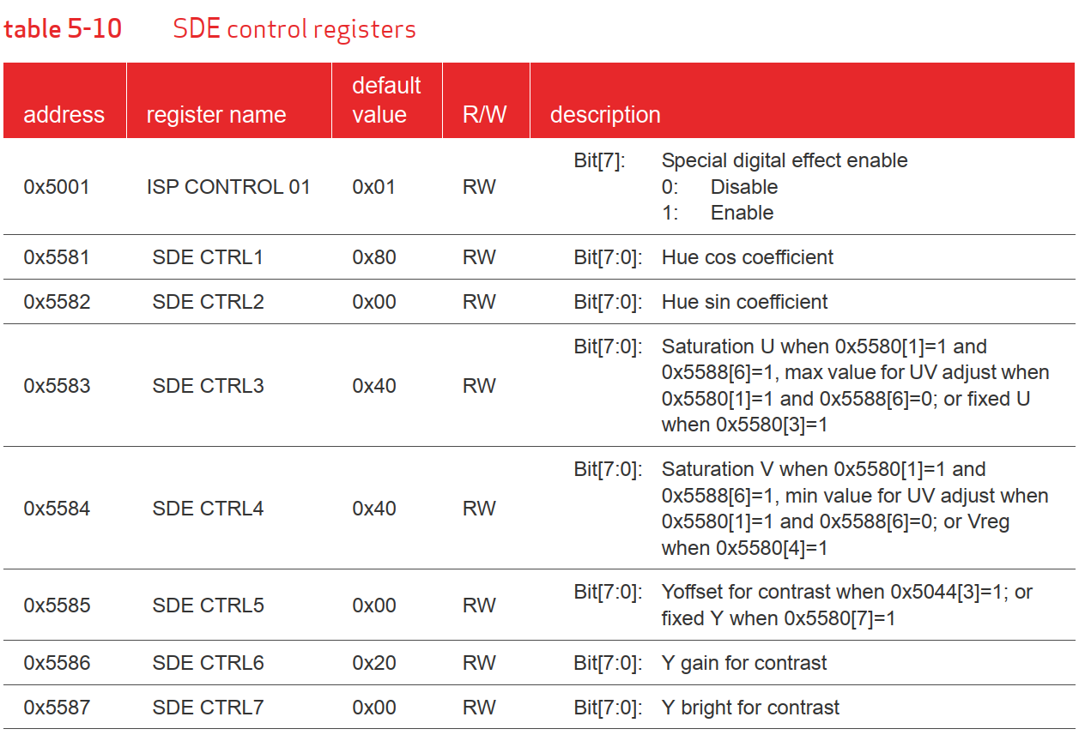

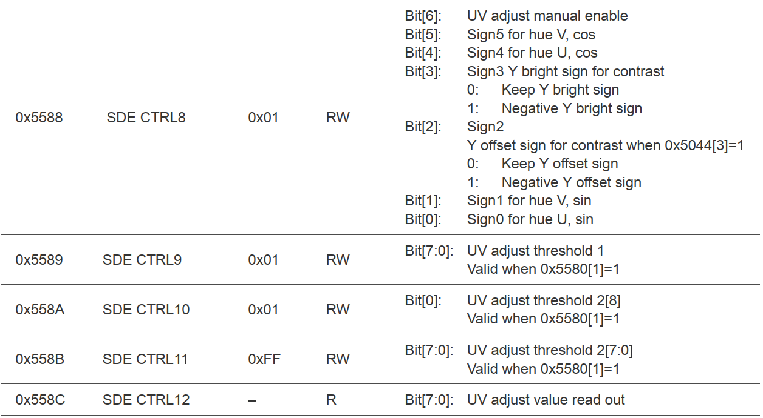

**5.10 UV adjust**

The UV adjust function is integrated in SDE. The main function of the UV adjust is to adjust the U/V channel value according to sensor gain. It supports both manual and auto modes.